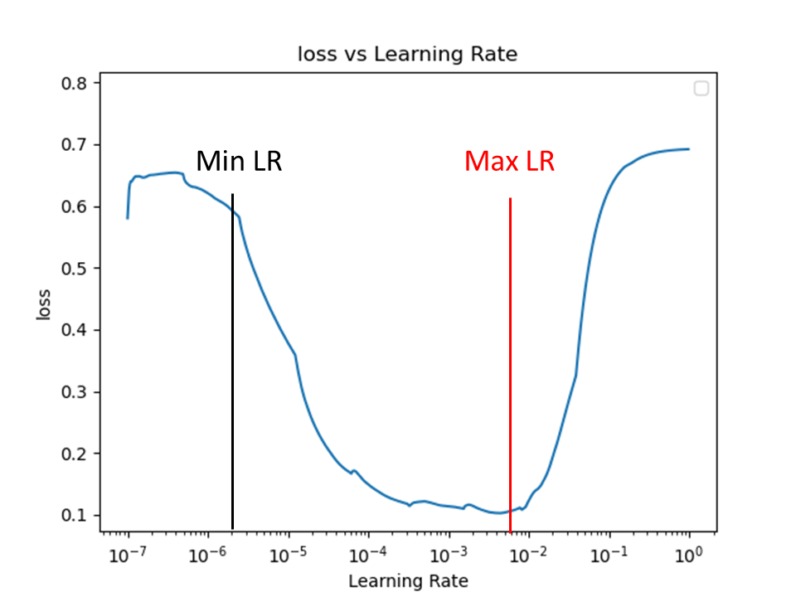
Supplementary Figure 1: Learning rate finder figure. The learning rate is gradually increased from 10e-7 to 10e-0; the point where loss begins to decrease is the minimum learning rate (min LR), and the point where it begins to increase is the maximum learning rate (max LR).

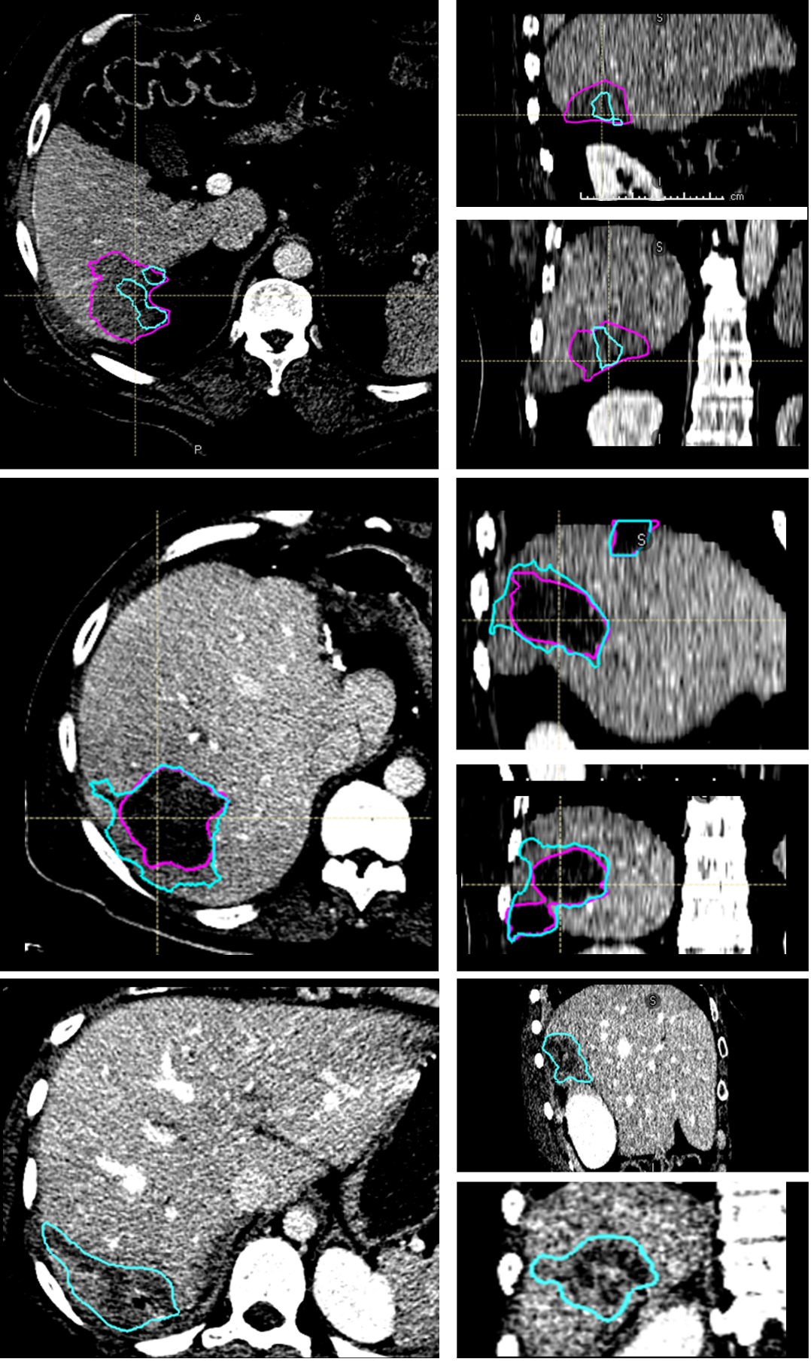
Supplementary Figure 2: Three cases where majority voting had a Likert Score less than 4. (Top) We believe that the top failed due to similarity in appearance to the gallbladder. (Middle, Bottom) Model over-segmented regions around the ablation zones.

